[Upload Jenkins Build Artificats to Amazon S3](http://sanketdangi.com/post/62877462188/upload-jenkins-build-artifacts-amazon-s3)

My previous two blogposts talks about [jenkins installation and configuration on Amazon Linux](http://sanketdangi.com/post/62715793234/install-configure-jenkins-on-amazon-linux) and [jenkins integration with GitHub to trigger automatic build process.](http://sanketdangi.com/post/62740311628/integrate-jenkins-github-trigger-build-process)

This post focus around uploading build artifacts to amazon s3.

To upload your build artifacts to amazon s3, create a S3 bucket.

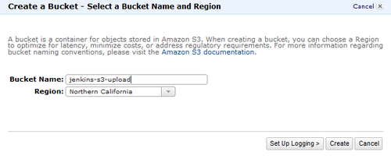

Once done, navigate to Jenkins dashboard -> Manage Jenkins -> Manage Plugins and select available tab. Look for “S3 plugin” and install that.

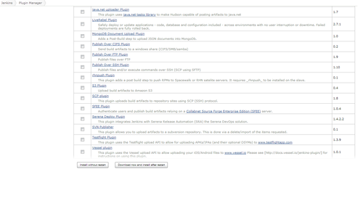

Once done, go back to Manage Jenkins and select “Configure System” and look for “Amazon S3 Profiles”. Please provide a profile name, access key and secret access key for your AWS account. Don’t provide ROOT AWS User credentials. Create an IAM user will S3 permissions.

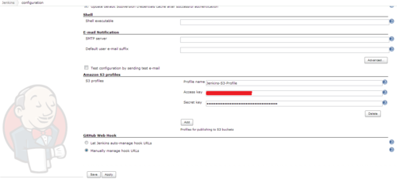

Once done, create a job under “Build a free-style software project”.

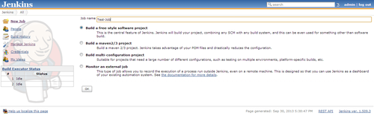

Navigate down to “Post-Build Actions” and click on “Add Post-Build Action” and select “Publish Artifacts to S3 Bucket”.

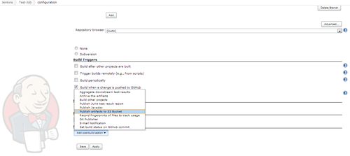

Then, select your S3 profile, pass source of the files to upload (if you want to upload all files, please use “ * ” else provide valid path), destination bucket name.

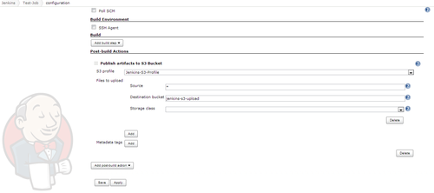

Now, click on save and you are done !!

All your build artifacts will get uploaded to Amazon S3 bucket.

Other Links :

[Install and Configure jenkins on Amazon Linux](http://sanketdangi.com/post/62715793234/install-configure-jenkins-on-amazon-linux)

[Integrate jenkins with GitHub to trigger automatic build process on code commit.](http://sanketdangi.com/post/62740311628/integrate-jenkins-github-trigger-build-process)